TFL WOWT Post Install Tasks

As part of the WOWT installation 3 processes are installed, these are required to refresh the data for the PODs.

The following steps need to be followed to submit the processes into the process framework.

# Process Types

In the process type’s module, check that the three new process types exist, they are:-

Generate Work Order Work Tray Data1, Generate Work Order Work Tray Data2 and Generate Work Order Work Tray Data3.

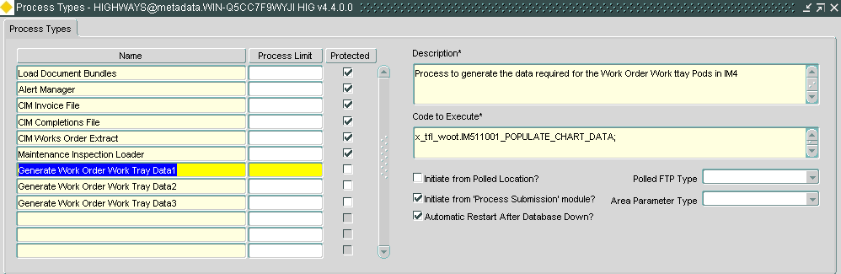

# Submit Processes

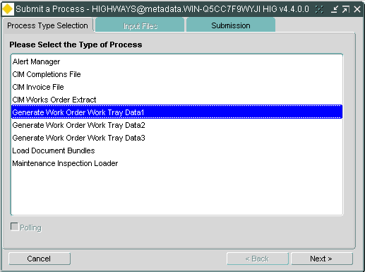

In the Submit process module select Generate Work Order Work Tray Data1 and press the Next button.

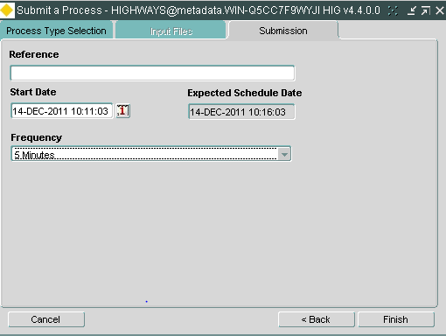

Select the frequency of 5 minutes and hit the finish button.

Repeat the above steps for the process types Generate Work Order Work Tray Data2 and Generate Work Order Work Tray Data3.

The processes can now be monitored via the Process monitor module, for further information please refer to the Exor product documentation.